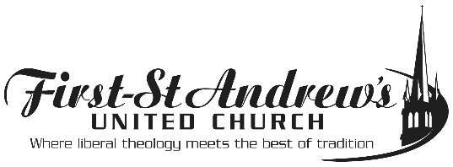
IDENTIFICATION OF NEXT OF KIN
NAME OF CONGREGANT___________________________________________________
ADDRESS________________________________________________________________
TELEPHONE_______________________E-MAIL_________________________________
I grant permission for First-St. Andrew’s United Church to identify the following next of kin for pastoral care purposes or in the event of an emergency or death. This information will be treated confidentially by FSA staff and the Pastoral Care team
NAME___________________________________________________________________
ADDRESS_________________________________________________________________
TELEPHONE_______________________E-MAIL__________________________________

NAME____________________________________________________________________
ADDRESS__________________________________________________________________
TELEPHONE_______________________E-MAIL___________________________________

NAME____________________________________________________________________
ADDRESS__________________________________________________________________
TELEPHONE_______________________E-MAIL___________________________________

SIGNATURE_________________________________ DATE_______________________
TELEPHONE CONSENT OBTAINED_______________________ DATE___________________

